**GROUP 6**

**PHONEBOOK USER MANUAL**

Table of Contents

**INTRODUCTION1**

Main Display1

**PHONEBOOK FEATURES**2

Adding a contact2

Changing a contact6

Removing a contact7

Searching for a Contact8

Resetting the Screen9

**INTRODUCTION**

The phonebook application is designed to allow you to quickly store, search, change and delete your contact list. It can be used as an alternate method to store and backup your contacts, and it can also be used as a proactive means to protect and retain contact information in the event a cell phone is lost, stolen or broken. It can be used for business or personal contacts.

**Main Display**

The main display screen puts everything right at your fingertips. When the application is first opened all of your contacts will display on the main screen with a scroll bar to scroll through the complete list. When you first download the application with no contacts stored in the database your main screen will appear as shown below:

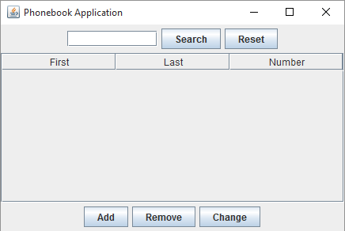

**PHONEBOOK FEATURES**

Each feature of the phonebook allows the user to see their changes immediately. Anytime a contact is added, changed or deleted the update will appear on the main screen as soon as the update is made.

**Adding Contact**

1. To add a contact, click the Add button on the main screen.



1. An empty pop up window will appear with blank text fields for you to add your contacts information.

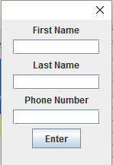

1. Enter your contact information in the respective fields:
   * First Name
   * Last Name
   * Phone Number

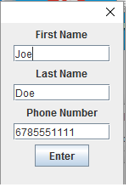

1. Press enter to store the contact information and update the display on the main screen.

*\*\*Note:*

* *Any empty field will be prepopulated as such. (i.e. “No First”, “No Last”, “0000000000”).*
* *All phone number entries must be 10 digits or the system will not update.*

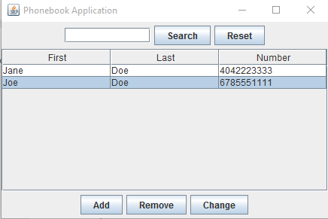

**Changing a Contact**

1. To change a contact’s information, select the contact you wish to change on the main display screen.
2. Once the contact you want to change is highlighted, click the change button.



1. A pop up window will display that is prepopulated with the selected contact information.

Once the pop up window displays, update the fields you want to change with the new contact information.

1. Once you are done with your updates click the enter button to complete the change.

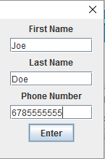

1. After you click the enter button the pop up window will close and the main screen will display the contact with the new updated information.

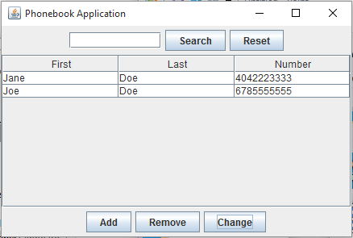

**Removing a Contact**

1. To remove a contact, select the contact you wish to remove on the main display screen.
2. Once the record you want to delete is highlighted, click the remove button.

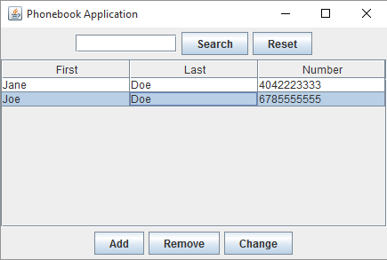

1. The main screen display will update showing that the record has been removed.

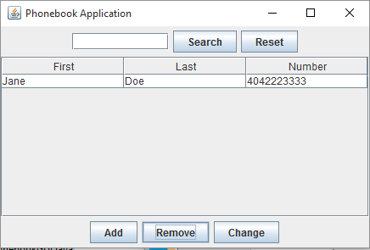

**Searching for a contact**

1. To search for a contact, enter **one** of the following search criteria in the search text box:

* First Name
* Last Name
* Or Phone number

1. Once your search key has been entered, press the search button.

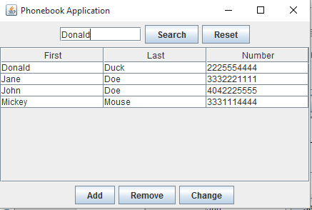

1. Only the record(s) that matches your criteria will appear on main screen display.

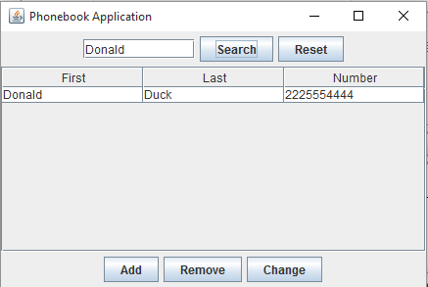

**Resetting the screen**

1. To reset the screen after a search, click the reset button.
2. This will take you back to the main screen display, where you can view all of your contacts.

